**STORE MANAGEMENT SYSTEM**

The project we are doing is Store Management System. In this we have 2 modules

1. **Admin Module**
2. **Customer Module**

* **Data Flow**

**Diagram (1): Data Flow Diagram**

**SDD1 – Administrator (Admin) Module**

SDD1.1 - The admin needs to login to the page using the username and password.

SDD1.2 – The admin Menu would consist of following options like:

1. Add Product
2. Modify the product
3. Delete the product
4. Reorder the product
5. Back to main menu

SDD1.3 - The admin could add the details of a given product.

SDD1.4 - The admin has the option to remove the products from list.

SDD1.5 - The admin can also modify the old product details and update it.

SDD1.6 – The admin also has the option to reorder the product.

SDD1.7 - The last option of this menu is to navigate backward.

**Admin UML Diagram**

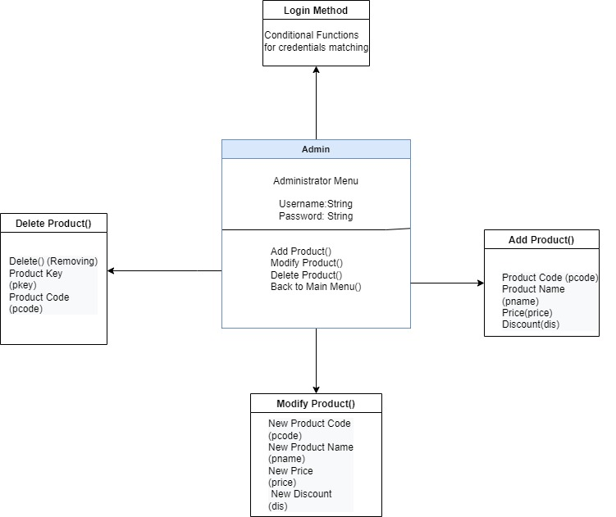**Diagram (2): Admin UML Diagram**

**Class Description**

**SDD1.7 - Admin Class {}** 🡪 This class consist of all the member functions and variables required by customer.

**Member variables** 🡪 Username: string, Password: string

**Member Functions** 🡪 Login() , AddProduct() , RemoveProduct(), Modify(), Delete().

**Description of Member Function**

**SDD1.8 - Login() :**

Parameter:

Username: string

Password: string

Description: Here we have use conditional functionality for matching the credentials for a successful login.

**SDD1.9 - ADD ()** 🡪This function add the details of new product**:**

Parameter:

Product Code (integer)

Product Name (string)

Price(double)

Discount(double)

Description: This function adds the details of entered new product and update it into the available list.

**SDD1.10 -Delete() 🡪:** This function is to delete the details of a selected product.

Parameter:

Product key(integer)

Token (integer)

Description: It remove the records of required product to be deleted through product key matching

**SDD1.11Modify() 🡪:** This function is used for modification in the details of added product i.e., price, discount etc...

Parameter:

Product Key (Integer)

Product Code(Integer)

Token (integer)

Description: Use of conditional statements in order to match the credentials through product key after that updating details as a new product.

**SDD1.7 - Items Class {}** 🡪This class include all the details of the product

Parameter:

Product Name (String)

Product Code (Integer)

Product Unit (Integer)

Description: This class would store the information of all the products which are taken by admin.

**SDD2 - Customer Module:**

SDD2.1 – From the above menu if the user continues as a customer then he would be directed to customer menu.

SDD2.2 – The interface of the buyer menu is as follow:

1. Purchase Product
2. Show all product
3. View Bill

SDD2.3 – The customer can proceed for purchasing the desired product.

SDD2.4 – After the selection of required product from the customer which has to be bought then the module will be processed to billing.

SDD2.5 – At the end after confirmation of place order the bill would displayed as a receipt.

Customer UML Diagram:

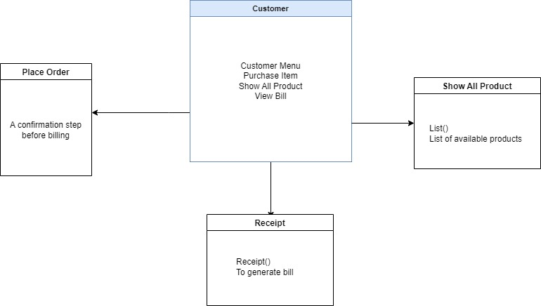

**Diagram (3): Customer UML Diagram**

**Function Description**

**SDD2.7 – Customer()** 🡪 This function is a base function for the customer menu and it uses switch case to carry out the task of other functions which are included.

**Member Functions** show(), bill(), menu()

**SDD2.8 – show()**: This function displays all the products in a list which are available for the customer to buy.

**SDD2.8 – bill()**: This function contributes to the bill management system and is responsible for billing.

Parameter:

Bill No (Integer)

Name (Integer)

Qty (integer)

**Diagram (4): Component Level Diagram**

**Flow Chart:**

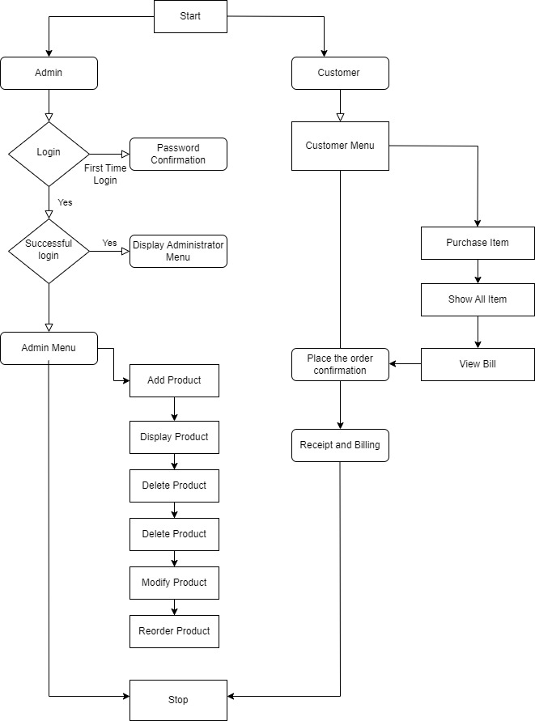

**Explanation:**

The flow chart consists of two stages

1. Admin
2. Customer

**Admin**

The admin is first required to login after successful login the administrator menu would be displayed which will have the following option.

1. Add product
2. Display Product
3. Delete Product
4. Modify Product
5. Reorder Product

In add product the admin can add the products and save its details.

In display all the available products would be displayed.

Modify product involves modification of the previous added product.

In delete product the record of a selected product is deleted.

**Customer**

Here the customer has following option in its menu

1. Purchase Product
2. Show all product
3. View Bill

The customer will purchase the product from the available list.

After selecting the required product to be bought through product id further it will ask for confirmation of purchase

After confirmation the receipt will be generated through billing management.

At the end a receipt would be displayed of the given product which has been bought.

**REVISION HISTORY**

|  |  |  |  |  |
| --- | --- | --- | --- | --- |
| Sr No. | Author | Version | Date of Modify | Remarks |
| 1. | Chanakya | V 1.0 | 25-10-22 | Basic Skeleton |
| 2. | Shubham | V 1.1 | 26-10-22 | Appending new function |
| 3. | Shashank | V 1.2 | 27-10-22 | Tagging and Finalization |